|  |
| --- |
|  |
|  |

Instructor Lab Manual

OOP: Object Oriented Programming

CS230 - IT232 - CS140 – IT401



**College of Computing & Informatics**

**SAUDI ELECTRONIC UNIVERSITY**

Week 6-7

**Exercise 1:**

Write a java program that ask the user to enter tow **positive** numbers. If the user enter a negative number, then the program keep asking him\her to renter a positive one. Finally, the program print the sum of the tow numbers.

**Typical run of the program**

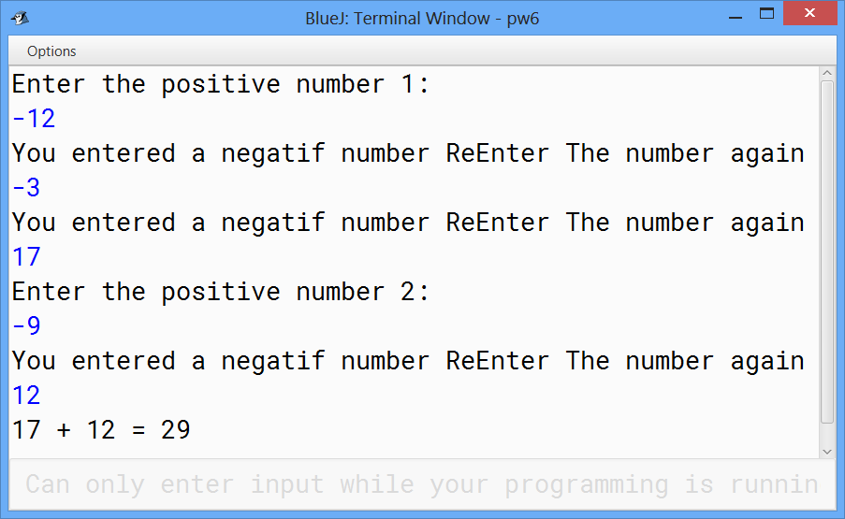

**Exercise 2:**

Write a java program that ask the user to enter his\her grade. The grade must be between 0 and 100, and then print if the user succeed or fail. To succeed the grade must be greater then 60.

**Typical run of the program**

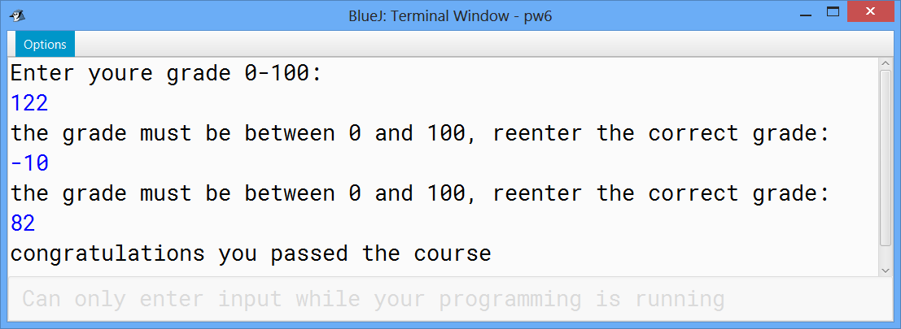

**Exercise 3:**

Write a java program, using the while loop, that:

* Ask the user to give a positive number less than 100.
* Print all the numbers from the given number to 200.

**Typical run of the program**

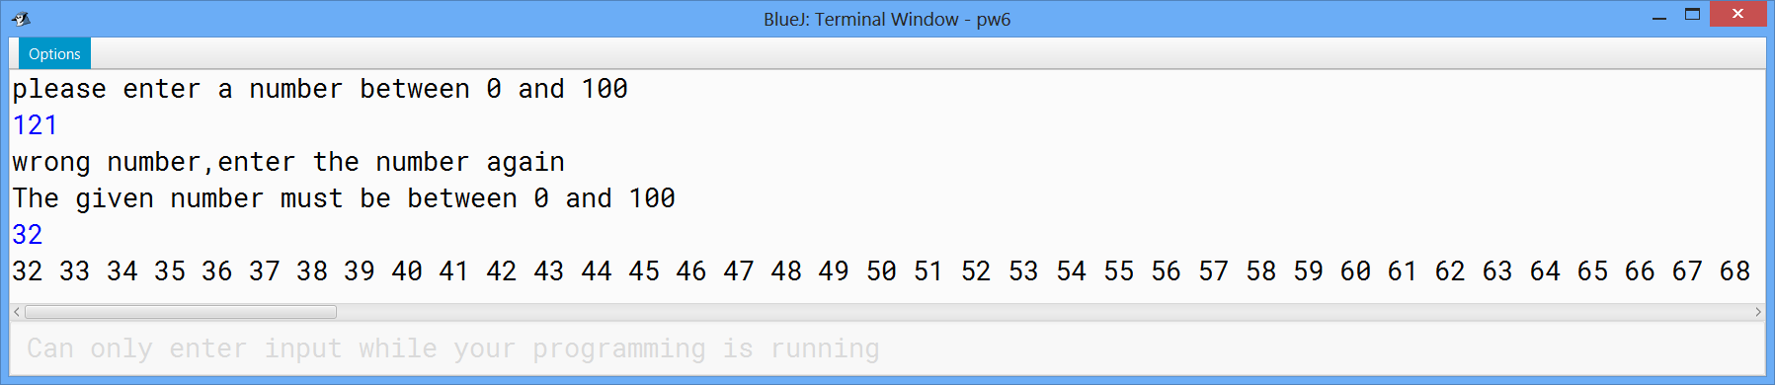

**Exercise 4:**

Write java program that ask the user to enter a number between 50 and 100 then print all the multiple of 5 from zero to the given number.

**Typical run of the program**

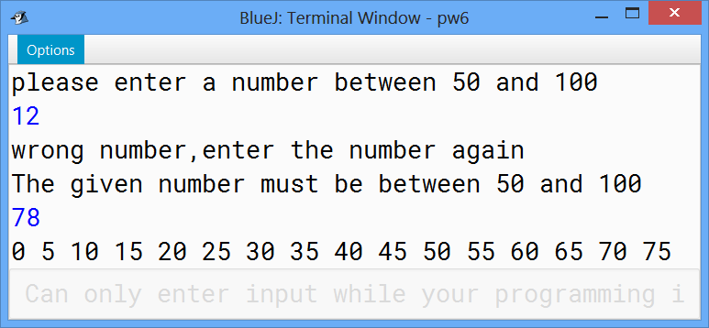

**Exercise 5:**

Write java program that ask the user to enter a number between 50 and 100 then print all the multiple of 5 from the given number to 200.

**Typical run of the program**

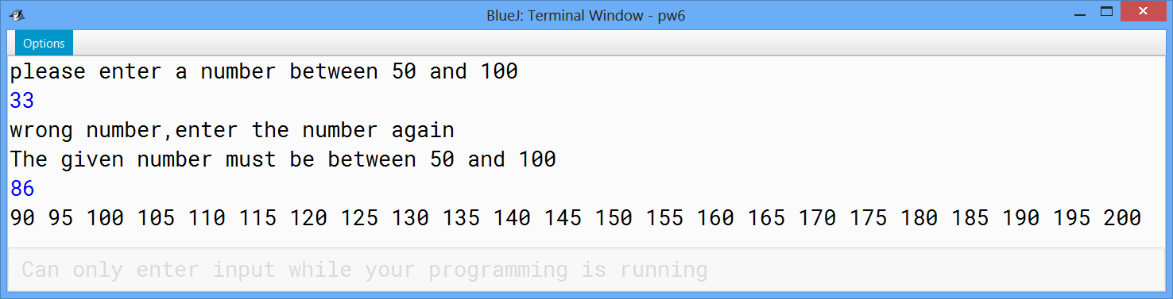

**Exercise 6:**

 An old men wants to buy a new or an antique car. He wants that the age of the car will be between 0 and 3 years or between 40 and 50 years.

Write a java program that asks the user to give a number that must be between o and 3 or between 40 and 50. The program keeps asking the user to give that number until getting a suitable one. Finally, depending on the given number the program print "old car" or "new car".

**Typical run of the program**

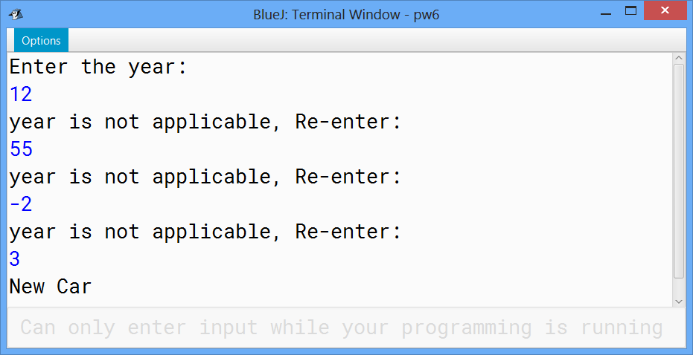

**Exercise 7:**

 Write a java program that asks the user to give a number between 1 and 7. Use the "switch" keyword to print the corresponding day. For example, if the user enters number 4, the program will print Wednesday.

**Typical run of the program**

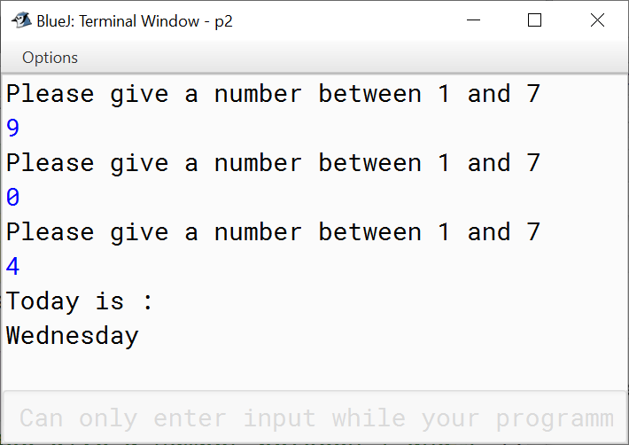

**Exercise 8:**

 Write a java program that act as a simple calculator using the switch statement.

**Typical run of the program**

